**SCADA HACKING**

**A PROJECT REPORT**

###### ***Submitted by***

##### Jayshree Karmakar (20BCY10042)

**Rupesh Kumar** (20BCY10057)

**Priyam Dabli** (20BCY10095)

**Shivam Kumar** (20BCY10206)

**Samarth Rajput** (20BCY10208)

*in partial fulfillment for the award of the degree*

*of*

**BACHELOR OF TECHNOLOGY**

*in*

# **COMPUTER SCIENCE AND ENGINEERING**



**SCHOOL OF COMPUTING SCIENCE AND ENGINEERING**

**VIT BHOPAL UNIVERSITY**

**KOTHRIKALAN, SEHORE**

**MADHYA PRADESH - 466114**

##### NOV 2023

**VIT BHOPAL UNIVERSITY, KOTHRIKALAN, SEHORE**

**MADHYA PRADESH – 466114**

**BONAFIDE CERTIFICATE**

Certified that this project report titled **“ SCADA HACKING”** is the bonafide work of “ **Jayshree karmakar(20BCY10042), Rupesh Kumar(20BCY10057), Priyam Dabli(20BCY10095),Shivam Kumar(20BCY10206), Samarth Rajput(20BCY10208)”** who carried out the project work under my supervision. Certified further that to the best of my knowledge the work reported at this time does not form part of any other project/research work based on which a degree or award was conferred on an earlier occasion on this or any other candidate.

**PROGRAM CHAIR PROJECT GUIDE**

Dr. D. Saravanan Dr Muneeswaran V

School of Computer Science and Engineering School of Computer Science and Engineering

VIT BHOPAL UNIVERSITY VIT BHOPAL UNIVERSITY

**ACKNOWLEDGEMENT**

First and foremost I would like to thank the Lord Almighty for His presence and immense blessings throughout the project work.

I wish to express my heartfelt gratitude toDr. D. Saravanan, Program Chair, Cyber Security and Digital Forensics, for much of his valuable support and encouragement in carrying out this work.

I would like to thank my internal guide Mr./Ms. Dr Muneeswaran V,for continually guiding and actively participating in my project, giving valuable suggestions to complete the project work.

I would like to thank all the technical and teaching staff of the School of Aeronautical Science, who extended directly or indirectly all support.

Last, but not least, I am deeply indebted to my parents who have been the greatest support while I worked day and night for the project to make it a success.

**LIST OF TABLES**

| **TABLE NO.** | **TITLE** | **PAGE NO.** |
| --- | --- | --- |

**ABSTRACT**

The project presented a comprehensive exploration of SCADA system vulnerabilities, simulated attacks, and potential threats. It outlined a risk reduction methodology, emphasizing elapsed time for successful attacks. The outcomes included detailed documentation of vulnerabilities, proof-of-concept exploits, and actionable insights for enhancing SCADA security. The project's real-world applicability extends to informing policy decisions and shaping industry best practices. It identified limitations such as cybersecurity risks, interoperability challenges, and human factors. Future enhancements aim to refine the compromise graph model and develop a user-friendly tool for risk analysis and secure system design, contributing to a more resilient SCADA infrastructure.

**[PURPOSE-METHODOLOGY-FINDINGS]**

Purpose:

The purpose of SCADA (Supervisory Control and Data Acquisition) hacking is often driven by malicious intent, with the primary goal of exploiting vulnerabilities within industrial control systems (ICS) for various reasons. This can include economic espionage, disruption of critical infrastructure, political motivations, or even acts of cyber warfare. By compromising SCADA systems, attackers can gain unauthorized control over essential processes, leading to potential physical damage, operational disruptions, or unauthorized access to sensitive information.

Methodology:

SCADA hacking involves various sophisticated techniques to exploit vulnerabilities within the control systems. Common methodologies include: Exploiting Vulnerabilities: Identifying and exploiting weaknesses in SCADA software, hardware, or network infrastructure to gain unauthorized access. Social Engineering: Manipulating individuals within the organization through phishing, pretexting, or other social engineering techniques to acquire sensitive information or access credentials. Malware Attacks: Deploying malicious software to infect SCADA systems, allowing unauthorized access, data manipulation, or disruption of operations. Zero-Day Exploits: Leveraging undiscovered vulnerabilities (zero-day exploits) in SCADA software before developers release patches. Insider Threats: Exploiting individuals with insider access to SCADA systems, either through coercion, bribery, or disgruntled employees seeking to cause harm.

Findings:

The findings of SCADA hacking can have severe consequences, including: Operational Disruption: Attackers can disrupt critical infrastructure, leading to shutdowns, delays, or even physical damage to equipment. Data Manipulation: Unauthorized access allows attackers to manipulate data, leading to misinformation, faulty decision-making, or even safety hazards. Financial Loss: Businesses and organizations relying on SCADA systems may incur financial losses due to downtime, recovery costs, and potential legal consequences. National Security Threats: SCADA hacking poses a significant threat to national security, especially if critical infrastructure such as power plants, water treatment facilities, or transportation systems are compromised. Loss of Public Trust: Incidents of SCADA hacking can erode public trust in the affected organizations, especially when dealing with essential services vital to public welfare. Given the potentially severe consequences, safeguarding SCADA systems through robust cybersecurity measures is essential to prevent unauthorized access and protect critical infrastructure.

**TABLE OF CONTENTS ()**

| **CHAPTER NO.** | **TITLE** | **PAGE NO.** |
| --- | --- | --- |
|  | List of Abbreviations  List of Figures and Graphs  List of Tables  Abstract | iii  iv  v  vi |
| 1 | **CHAPTER-1:**  **PROJECT DESCRIPTION AND OUTLINE** Introduction 1.2 Motivation for the work  1.3 Scada Hacking Introduction  1.5 Problem Statement  1.6 Objective of the work  1.7 Organization of the project  1.8 Summary | 1  .  .  . |
| 2 | **CHAPTER-2:**  **RELATED WORK INVESTIGATION**  2.1 Introduction  2.2 Case Study  2.3 Existing Approaches/Methods  2.3.1 Approaches/Methods -1  2.3.2 Approaches/Methods -2  2.3.3 Approaches/Methods -3  2.4 <Pros and cons of the stated Approaches/Methods >  2.5 Issues/observations from investigation  2.6 Summary | 14 |
| 3 | **CHAPTER-3:**  **REQUIREMENT ARTIFACTS**  3.1 Introduction  3.2 Hardware and Software requirements  3.3 Specific Project requirements  3.3.1 Data requirement  3.3.2 Functions requirement  3.3.3 Performance and security requirement  3.3.4 Look and Feel Requirements  3.3.5 ………  3.4 Summary | 15 |
| 4 | **CHAPTER-4:**  **DESIGN METHODOLOGY AND ITS NOVELTY**  4.1 Methodology and goal  4.2 Functional modules design and analysis  4.3 Software Architectural designs  4.4 Subsystem services  4.5 User Interface designs  4.6 Summary | 18 |
| 5 | **CHAPTER-5:**  **TECHNICAL IMPLEMENTATION & ANALYSIS**  5.1Outline  5.2 Technical coding and code solutions  5.3 Working Layout of Forms  5.4 Prototype submission  5.5 Test and validation  5.6 Performance Analysis(Graphs/Charts)  5.7 Summary | 23 |
| 6 | **CHAPTER-6:**  **PROJECT OUTCOME AND APPLICABILITY**  6.1Outline  6.2 key implementations outlines of the System  6.3 Significant project outcomes  6.4 Project applicability on Real-world applications  6.4 Inference | 29 |
| 7 | **CHAPTER-7:**  **CONCLUSIONS AND RECOMMENDATION**  7.1Outline  7.2 Limitation/Constraints of the System  7.3 Future Enhancements  7.4 Inference | 32 |
|  | Appendix A  Appendix B  References | 33 |

**CHAPTER - 2**

**RELATED WORK INVESTIGATION**

Researchers and cybersecurity professionals have often explored real-world incidents to understand the methods, motives, and consequences of SCADA hacking. Here's a general overview:

Stuxnet Worm (2010):

One of the most notorious SCADA-related incidents was the Stuxnet worm. Stuxnet specifically targeted supervisory control and data acquisition systems, particularly those used in Iranian nuclear facilities. It exploited zero-day vulnerabilities to sabotage industrial processes, showcasing the potential for cyber-physical attacks.

Ukraine Power Grid Attacks (2015 and 2016):

In Ukraine, there were two separate incidents where attackers successfully compromised SCADA systems, leading to power outages. These incidents highlighted the real-world impact of cyber attacks on critical infrastructure, affecting thousands of people.

Industroyer (CrashOverride) Malware (2016):

The Industroyer malware, also known as CrashOverride, targeted electrical grids. It demonstrated the capability to automate and coordinate attacks on power grids, emphasizing the sophistication of malware designed explicitly for SCADA systems. TRITON Malware (2017): The TRITON malware was designed to target industrial safety systems, aiming to manipulate or sabotage them. It marked one of the few known cases where malware was specifically developed to interfere with the safety mechanisms of a SCADA system.

Water Utility Hacks: Incidents involving the hacking of SCADA systems in water treatment and distribution facilities have raised concerns about the potential contamination of water supplies. Researchers have investigated these cases to understand the vulnerabilities and improve the security of critical water infrastructure. These case studies and investigations underscore the importance of cybersecurity for SCADA systems and the potential consequences of successful attacks. Researchers analyze such incidents to enhance threat detection, response mechanisms, and overall cybersecurity practices for critical infrastructure protection. As the field evolves, ongoing research continues to explore emerging threats and countermeasures to safeguard SCADA systems from cyber threats.

CHAPTER - 3

REQUIRED ARTIFACTS

Supervisory Control and Data Acquisition (SCADA) systems are used for controlling, monitoring, and analyzing industrial devices and processes. The system consists of both software and hardware components and enables remote and on-site gathering of data from the industrial equipment.

The primary difference between a PLC (or Programmable Logic Controller) and SCADA (Supervisory Control and Data Acquisition) is the fact that a PLC is hardware and SCADA is (generally) software, though some would argue that SCADA is a plant's overall control system using hardware and software elements.

Most SCADA supervisory control systems are now programmed using standard interfaces whenever possible. Most programs are written in C, or a derived programming language. As a SCADA professional, you are required to improve the functionality and performance of the software programs on your SCADA systems.

The three main components of a SCADA system are the Human Machine Interface (HMI), Remote Terminal Unit (RTU), and Programmable Logic Controller (PLC). Let's take a closer look at each of these components and their roles in the SCADA system.

**Human Machine Interface (HMI)**: The HMI is the interface through which operators interact with the SCADA system. It provides a graphical representation of the industrial processes and allows operators to monitor and control various parameters. The HMI presents real-time data in the form of visualizations, such as graphs, charts, and alarms, enabling operators to make informed decisions. It acts as the brain of the system, processing user inputs and providing feedback on the system's operational state.

The HMI offers a user-friendly environment with intuitive controls and displays, allowing operators to easily navigate and access relevant information. It enables operators to monitor process variables, set control parameters, and receive alarms and notifications. Additionally, the HMI provides tools for data analysis and reporting, facilitating performance evaluation and process optimization.

**Remote Terminal Unit (RTU)**: The RTU serves as a communication gateway between the field devices and the main control system. It collects data from sensors and field devices distributed across the industrial site and transmits this data to the central control system. The RTU is responsible for data acquisition, processing, and communication.

RTUs are designed to operate in harsh environments and are typically located close to the field devices they communicate with, such as pumps, valves, and sensors. They collect data from these devices, convert it into a standardized format, and transmit it to the control system. The RTU also receives commands from the control system and relays them to the field devices for control and automation purposes.

**Programmable Logic Controller (PLC)**: The PLC is a specialized computer system that performs control functions within the SCADA system. It is responsible for monitoring and controlling the various devices and processes based on inputs from sensors and commands from operators or the control system. The PLC executes pre-programmed logic instructions to make decisions and initiate control actions.

PLCs are designed to be robust, reliable, and capable of operating in industrial environments. They are programmable, allowing for flexibility and customization to meet specific control requirements. PLCs can interface with a wide range of devices, such as motors, valves, switches, and relays, enabling control and automation of industrial processes.

The combination of the HMI, RTU, and PLC forms the backbone of a SCADA system. The HMI provides the interface for operators to interact with the system, the RTU facilitates data acquisition and communication, and the PLC performs control functions based on the received data and commands. Together, these components enable efficient monitoring, control, and automation of industrial processes, leading to improved productivity, operational efficiency, and overall performance.

What are the 3 types of SCADA?

1. **Distributed SCADA System**: In this type of SCADA system, the control and monitoring tasks are distributed across multiple locations or sites. Each site typically has its own local control and data acquisition equipment, which communicates with a central master station. This architecture is suitable for large-scale operations where different locations need to be monitored and controlled from a centralized location.

2. **Centralized SCADA System**: This type of SCADA system has a single central control and monitoring station that oversees all the connected processes or equipment. All data acquisition, control, and visualization functions are performed at this central location. This architecture is simpler and easier to manage for smaller operations or processes that don't require distributed control.

3. **Hierarchical SCADA System**: A hierarchical SCADA system combines elements of both distributed and centralized architectures. It organizes control and monitoring tasks into multiple layers, each responsible for a specific level of control. Lower levels handle local control and data acquisition, while higher levels oversee the coordination and management of multiple lower-level systems. This type of architecture is well-suited for complex systems with varying degrees of control and monitoring requirements.

**REFERENCES**

1. Abdul-Wahab,S.A., Al-Alawi,S.M. and El-Zawahry, Patterns of S02 emission: a refinery case study, *Environmental modeling & software*, 2002, 17, 563-570.
2. Aggarwal A.L, Sivacoumar R. and Goyal SK Air Quality Prediction : influence of model parameters and sensitivity analysis, *Indian Journal of Environmental Protection*, 1997, 17(9), 650-655.

**<<< MLA/ APA/Chicago format of Google Scholar>>>**

Chapter - 4

**DESIGN METHODOLOGY AND ITS NOVELTY**

4.1 Methodology and goal :

Our proposed methodology is based on the assumption that risk is related to the elapsed time required for a successful attack. The following steps provide a basic description of this methodology:-

* Understand the System Setup
* Use a Risk Model to Identify Key Risks
* Prioritize Security Needs for the Main Targets
* Find Weaknesses in the System
* Sort Vulnerabilities by How They Could be Exploited
* Estimate How Long It Takes to Compromise Each Part
* Create Charts Showing Possible Compromises and Attack Paths
* Predict the Most Likely Attack Paths
* Guess How Much Risk Can Be Reduced

First Goal: Create a Better Way to Measure Risk Reduction in a SCADA System:- Our initial aim was to come up with a method to accurately measure how much risk is reduced in a specific SCADA control system. This method should give us numbers that make sense to both us and the customer, and it should be clearer than the general qualitative assessments we had done before. It also needed to be well-defined to serve as a basis for discussions and improvements involving various team members.

Second Goal: Use the Method on the CS60 System to Evaluate Security Improvements: After establishing the method, the next step was to apply it to the CS60 system. We wanted to see how much risk was reduced by the security improvements we had made based on the findings of the initial security review.

Third Goal: Demonstrate Efficient Collaboration Between Analysts and Hackers: We aimed to show that analysts and hackers could work together seamlessly. The method we developed should be executed efficiently, with effective communication and collaboration among team members who have different skills and interests. It's about finding a balance that works well for everyone involved.

4.2 Functional modules design and analysis:

SCADA system functional modules, design, and analysis. design involves several functional modules. Here is an overview:

* Human-Machine Interface (HMI): Function: Provides a graphical representation of the industrial process to operators. Allows users to monitor and interact with the system. Design Considerations: User-friendly interface, real-time data visualization, and efficient control options.
* Supervisory Control Module: Function: Enables operators to issue control commands to the industrial processes. Design Considerations: Secure authentication for control access, emergency shutdown procedures, and redundancy for critical operations.
* Data Acquisition Module: Function: Gathers data from sensors and field devices. Design Considerations: Compatibility with various types of sensors, data accuracy, and real-time data acquisition.
* Communication Module: Function: Manages communication between different components of the SCADA system. Design Considerations: Robust and secure communication protocols, encryption, and redundancy for communication links.
* Control Logic Module: Function: Implements the control algorithms and logic for the industrial processes. Design Considerations: Reliable and efficient control algorithms, fail-safe mechanisms, and compliance with industry standards.
* Database and Historian Module: Function: Stores historical data for analysis, reporting, and auditing. Design Considerations: Data integrity, scalability, and secure access controls for historical data.
* Alarm and Event Management Module: Function: Monitors the system for abnormal conditions and triggers alarms or events. Design Considerations: Timely notification of critical events, prioritization of alarms, and integration with the HMI.
* Security Module: Function: Protects the SCADA system from unauthorized access, cyber threats, and ensures data integrity. Design Considerations: Authentication mechanisms, encryption, intrusion detection, and continuous monitoring.

When analyzing SCADA systems, it's crucial to consider not only the functionality but also the security aspects to prevent unauthorized access and potential cyber threats. Regular security assessments, updates, and adherence to industry best practices contribute to maintaining a secure SCADA environment.

4.3 Software Architectural designs:

A SCADA framework is made up of both hardware and software components. On the hardware side, it includes devices like Remote Terminal Units (RTU), Master Terminal Unit (MTU), as well as actuators and sensors. On the software side, there are programs like the Human-Machine Interface (HMI), a central database known as the Historian, and other user software. These software components play a crucial role in establishing communication between the hardware components. In the physical environment, actuators and sensors are connected. These sensors gather information, and the data is then transmitted to the RTUs. The RTUs, in turn, collect data from the sensors and send telemetry data to the MTU. The Master Terminal Unit is responsible for observing and controlling the entire SCADA system. Further details about this interaction will be explained in the following section.

4.4 Subsystem services:

Monolithic SCADA systems operate in isolation without any connection to other systems, functioning independently. These systems were originally powered by large minicomputers, like the PDP-11 series developed by Digital Equipment Corporation, representing a first-generation SCADA system. In this setup, Remote Terminal Units (RTUs) communicated with the Master Terminal Unit (MTU) using Wide Area Networks (WAN), denoted as WAN∗ due to the unique protocols used during that era. During this time, WAN∗ protocols were in their early stages and were proprietary, meaning they were specific to connecting RTUs with MTUs from the same vendor. These protocols were limited to facilitating scanning, control, and data exchange between the MTU and RTUs. Without widespread network connectivity, the MTU and RTUs were connected at the bus level (e.g., using RS-232 communication standards) or through proprietary adapters plugging into the CPU backplane. Connecting RTUs from different vendors to the MTU was challenging due to the lack of open standards, highlighting the need for interoperability. To enhance the reliability of the SCADA system, some setups incorporated redundant systems, serving as backup systems connected to the master system.

4.5 User Interface designs:

Distributed SCADA systems were interconnected within localized networks like Local Area Networks (LAN), depicted in Fig. 6. However, the WAN/LAN protocols employed in this generation differed significantly from today's standards, denoted as WAN∗ and LAN∗. In this setup, computation tasks were distributed across multiple systems connected through LAN∗. Some systems served as communication processors, others as operator interfaces, and some as database servers, resulting in increased processing power and a more robust and redundant system. Distributed architecture proved beneficial for scenarios with multiple clients and stations, where information sharing occurred through LAN∗. However, certain LAN∗ protocols were proprietary, limiting systems connected to LAN∗ from functioning as a distributed MTU. WAN facilitated communication between RTUs and MTU. The range of LAN∗ protocols was confined to the local environment, limiting the total cable length between networked systems to 600 feet, restricting multiple system connections to a room. Similar to monolithic SCADA systems, distributed SCADA systems were constrained by proprietary hardware, software, network protocols, and peripheral devices provided by the vendor. Devices within the SCADA LAN∗ were unable to communicate with external devices using different communication protocols, remaining restricted to proprietary protocols from vendors. In summary, distributed SCADA systems exhibited increased openness at the MTU level but still lacked capabilities at the RTU. Security considerations were not a focal point in this generation either.

4.6 Summary :

The report outlines a methodology for SCADA system risk reduction, emphasizing the elapsed time for successful attacks. It details steps such as understanding the system setup, using a risk model, prioritizing security needs, identifying weaknesses, estimating compromise times, and creating attack path charts. The goals include creating a better risk measurement method, applying it to evaluate security improvements, and demonstrating efficient collaboration between analysts and hackers.The functional modules of a SCADA system are described, covering components like HMI, supervisory control, data acquisition, communication, control logic, database, alarm management, and security. The emphasis is on both functionality and security aspects.The SCADA framework includes hardware (RTU, MTU, sensors, actuators) and software (HMI, Historian). Monolithic SCADA systems operate in isolation, while distributed systems are interconnected through LAN. Proprietary protocols and lack of interoperability are highlighted. The summary emphasizes the need for security considerations in SCADA design.

**CHAPTER-5:**

**TECHNICAL IMPLEMENTATION & ANALYSIS**

**5.1 Outline**

In this module we will be demonstrating the techniques used by the threat actors to mount attack on critical infrastructure through SCADA Hacking. We will be recording our findings and analysis further in this report.

**5.2 Technical Analysis**

Our technical analysis will be based on these categories:

1. Based on “What attackers might know”
2. Based on “What attackers want to know”
3. Based on “What attackers will gain access to”

And based on these categories we would be performing the demonstration and aptly recording our findings.

**5.3 Working in Brief**

Our project would be working based on the 3 fundamental questions crucial in the domain of SCADA Hacking, we would be demonstrating based on these, to do so we are proceeding with the first phase of the SCADA Hacking. This step is crucial when talking about the initial stages of gathering information and accordingly proceeding.

**5.4 Performing The Demonstration**

We started with the first case , “What does attackers might know?” , since in the perspective of real life on ground situation they will have a specific ip address or atleast or a range of the ip addresses owned by the facility using SCADA devices that are exposed to the Internet.

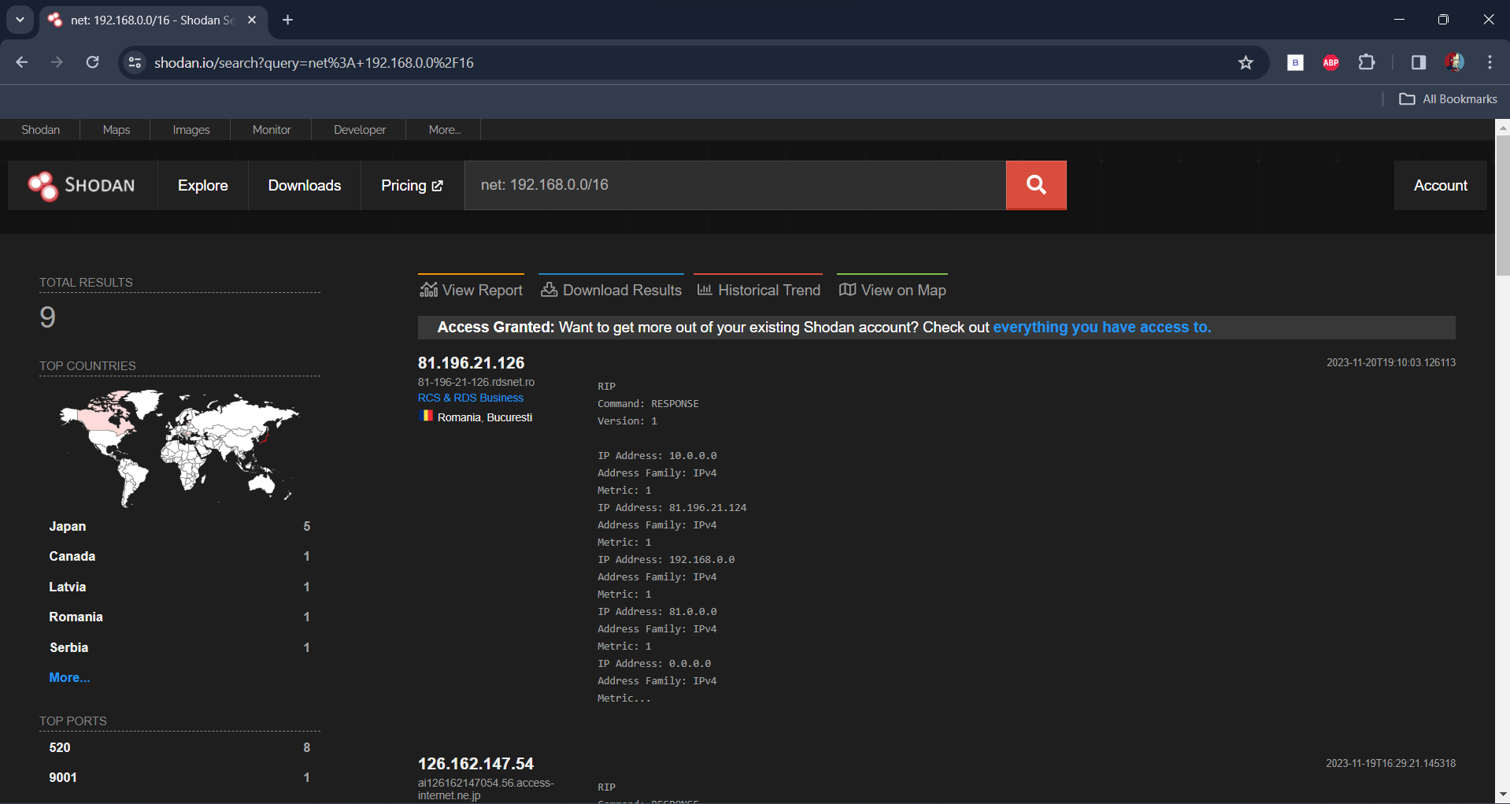

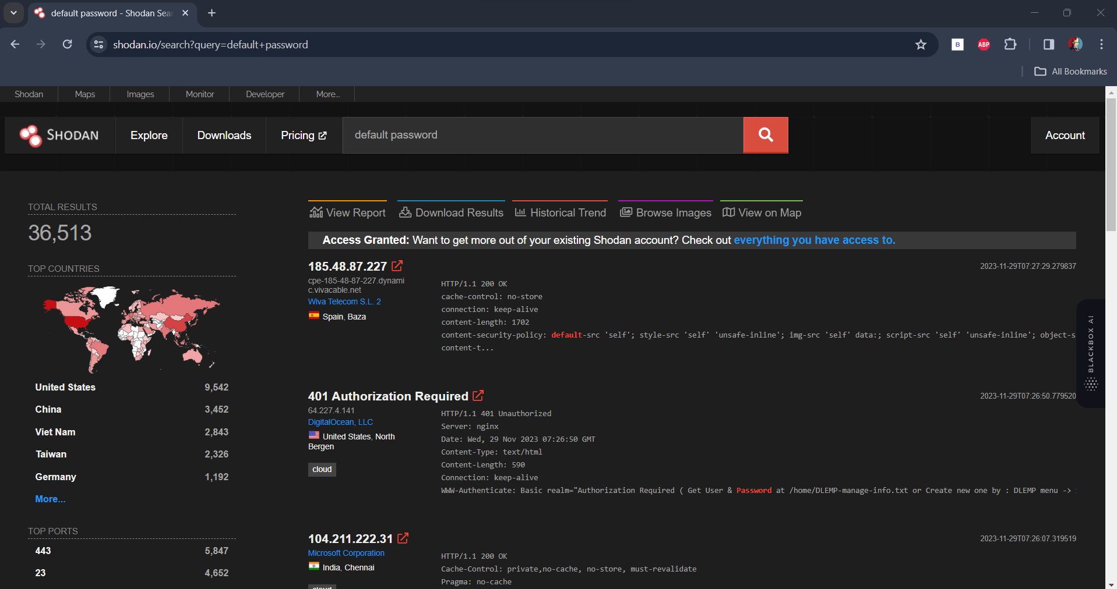

What attackers want to know

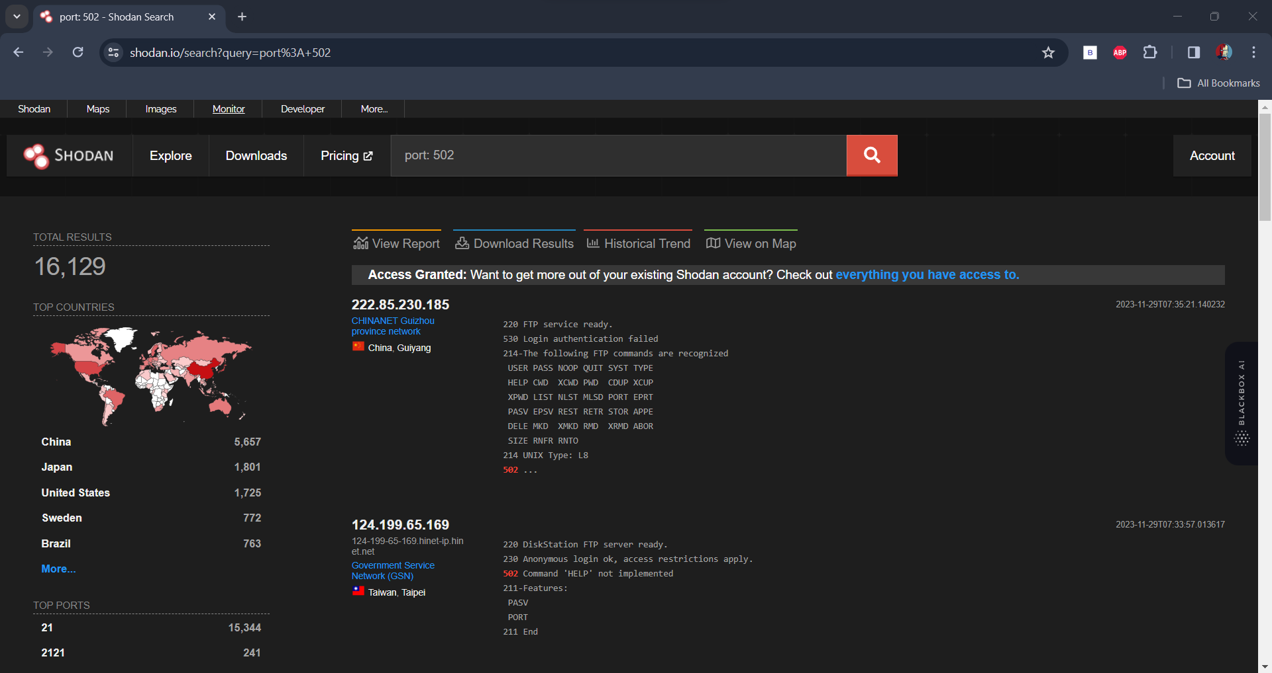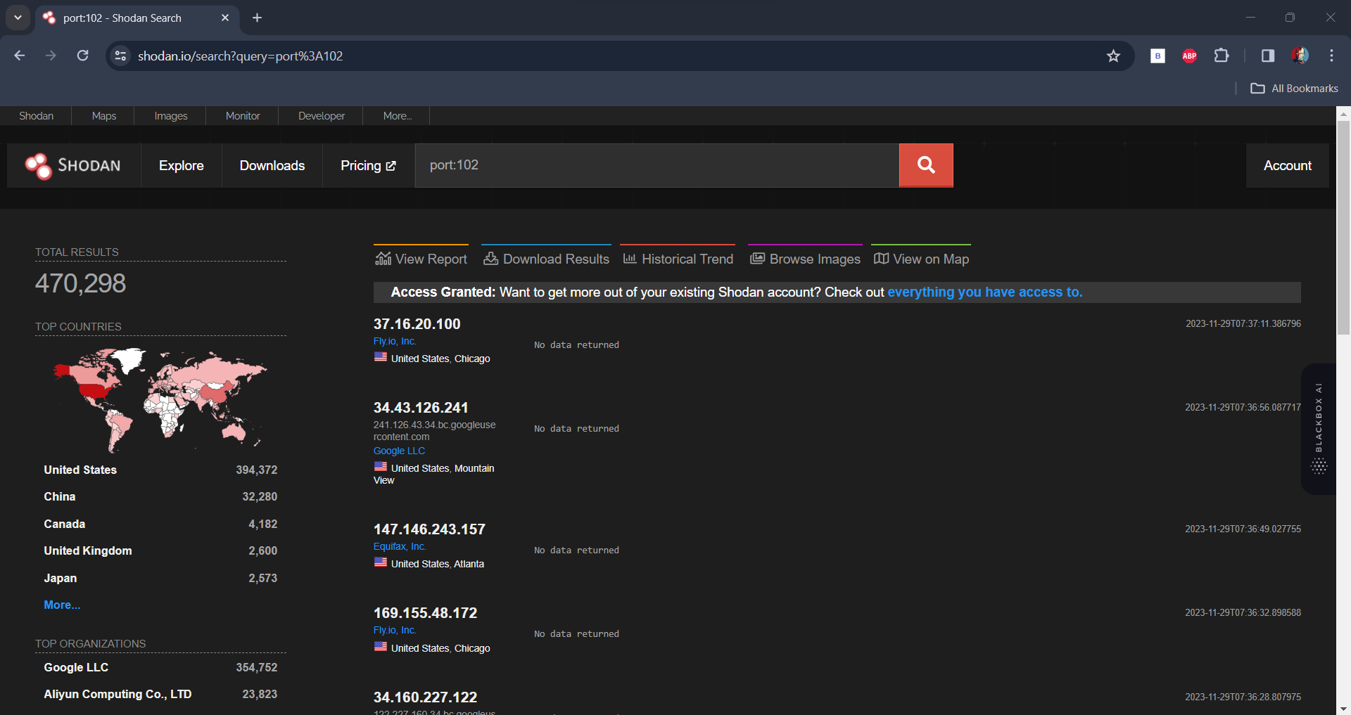

Now What attackers might gain access to?

Internal Login Portals:

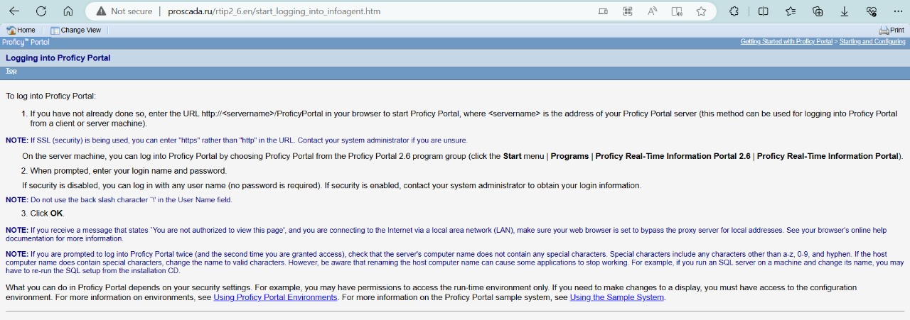

Then to internal servers:

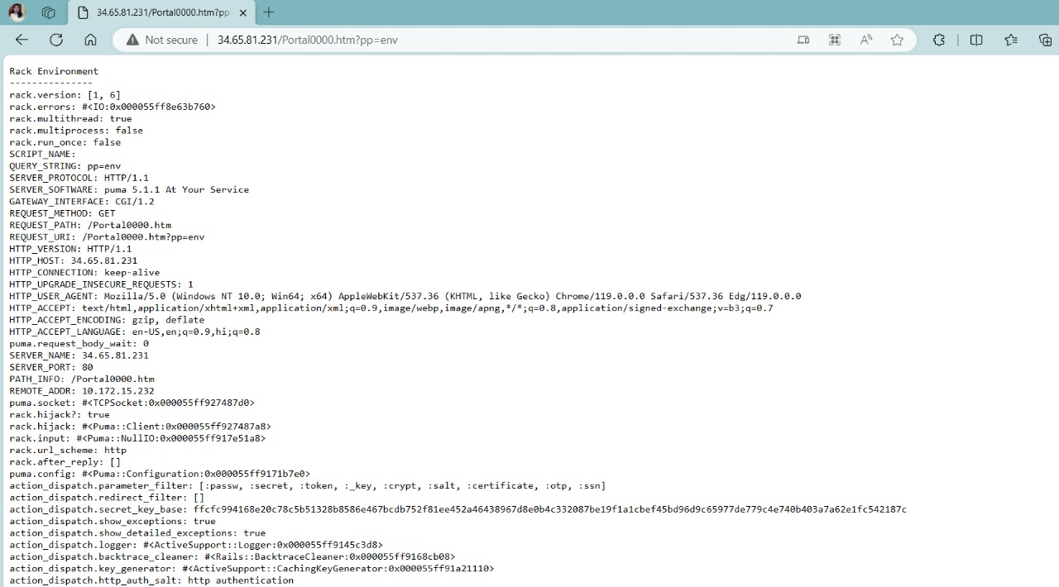

and then finally the SCADA device and monitoring system that when used as a weapon can bring a wide catastrophe in some parts or whole of the target nation.

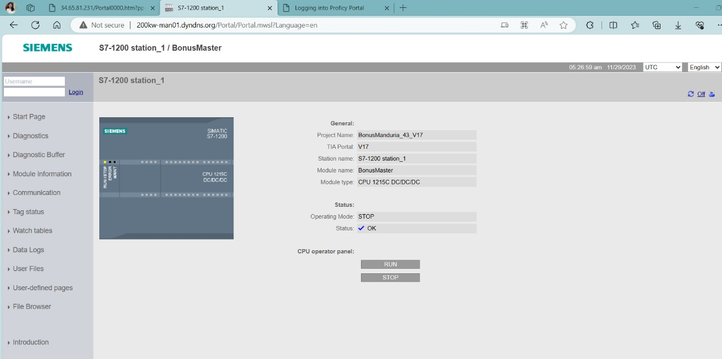

Chapter - 6

**PROJECT OUTCOME AND APPLICABILITY**

6.1 Outline:

This project is a comprehensive exploration into the security landscape of Supervisory Control and Data Acquisition (SCADA) devices, delving into the alarming issue of hacking and the potential threats posed by malicious actors. The outline commences with a thorough analysis of SCADA systems, elucidating their critical components and functionalities. It then progresses to an in-depth examination of the techniques employed by threat actors to compromise these systems, highlighting the vulnerability landscape and potential consequences of security breaches.

6.2 Key Implementations Outlines of the System:

The project encompasses a multifaceted approach to understanding SCADA device vulnerabilities and potential exploitation techniques. Key implementations involve simulated attacks designed to illustrate how threat actors could infiltrate these systems. This includes rigorous penetration testing, vulnerability assessments, and a meticulous analysis of common attack vectors such as malware, social engineering, and network-based attacks. The system also explores weaknesses in authentication mechanisms and encryption protocols that threat actors may exploit to compromise the integrity of SCADA systems.

Furthermore, the project involves the development of proof-of-concept exploits, providing hands-on insights into potential vulnerabilities. These implementations serve as practical demonstrations, offering a tangible understanding of the security risks associated with SCADA systems.

6.3 Significant Project Outcomes:

The project's outcomes are far-reaching and contribute significantly to the field of SCADA security. It produces detailed documentation of vulnerabilities discovered during the simulated attacks, potential entry points for attackers, and a comprehensive analysis of the potential impact of successful breaches on SCADA systems. Additionally, the project aims to propose effective countermeasures and preventive strategies to mitigate the identified risks.

The outcomes serve as a valuable resource for both the cybersecurity community and SCADA system operators. They provide a nuanced understanding of the evolving threat landscape and equip organizations with the knowledge needed to enhance their security postures effectively. The project outcomes go beyond theoretical considerations, offering actionable insights that can be implemented to bolster the resilience of SCADA environments against emerging cyber threats.

6.4 Project Applicability on Real-World Applications:

The findings of the project are highly applicable to real-world scenarios, given that SCADA systems are integral components of critical infrastructure across various sectors, including energy, water, and manufacturing. By simulating real-world threats and vulnerabilities, the project provides insights that can be directly applied to enhance the security posture of operational SCADA environments.

The project's applicability extends to informing policy decisions and shaping industry best practices. Organizations responsible for critical infrastructure can utilize the project outcomes to tailor their security strategies, thereby fortifying their SCADA infrastructure against potential cyber threats. The real-world applicability of the project ensures that its findings have a tangible and lasting impact on the security of SCADA systems.

6.5 Inference:

In conclusion, the project underscores the pressing need for heightened security measures in SCADA systems. The outlined techniques used by threat actors emphasize the urgency for robust preventive measures. The findings and recommendations presented in the project provide a comprehensive roadmap for stakeholders to fortify their SCADA infrastructure, contributing to a more resilient and secure industrial control ecosystem. The project's depth and breadth of analysis position it as a valuable resource for advancing the understanding of SCADA security and promoting proactive measures to safeguard critical infrastructure from evolving cyber threats.

Chapter - 7

**CONCLUSIONS AND RECOMMENDATION**

7.1 Outline:

outlines a for SCADA system risk reduction, emphasizing the elapsed time for successful attacks. It details steps such as understanding the system setup, using a risk model, prioritizing security needs, identifying weaknesses, estimating compromise times, and creating attack path charts. The goals include creating a better risk measurement method, applying it to evaluate security improvements, and demonstrating efficient collaboration between analysts and hackers.

7.2 Limitation/Constraints of the System:

SCADA (Supervisory Control and Data Acquisition) systems, while essential for industrial automation and control, have certain limitations and constraints. Here are some common ones: Security Concerns:

Cybersecurity Risks: SCADA systems are vulnerable to cyber threats, including malware, hacking, and other cyber-attacks, which can lead to serious consequences such as system disruptions, data breaches, or even physical damage. Interoperability Challenges: Vendor-Specific Protocols: Many SCADA systems use proprietary communication protocols, making it challenging to integrate devices or components from different vendors. This lack of interoperability can result in limited flexibility and increased costs. Legacy System Issues: Outdated Technology: Some SCADA systems still rely on legacy technologies, which may lack support and updates. This can lead to compatibility issues with modern hardware and software. Limited Bandwidth and Network Issues: Communication Constraints: SCADA systems often operate in environments with limited bandwidth, affecting the speed and reliability of data transmission. Network failures or congestion can impact real-time monitoring and control. Human Factor: Operator Training: SCADA operators require specialized training to effectively monitor and respond to system events. The complexity of the system can lead to errors or delays in responding to critical situations. Maintenance Challenges: Downtime for Maintenance: Performing maintenance or updates on a SCADA system may require downtime, impacting operations. Planning and executing maintenance activities without disrupting the production process can be challenging. Scalability Issues: Scalability Constraints: Expanding or upgrading a SCADA system may be complex and costly. Scalability challenges can arise when trying to accommodate additional devices or scale the system for a larger operational scope. Limited Remote Access: Remote Monitoring Challenges: Some SCADA systems may face limitations in providing secure remote access for monitoring and control. This can be a constraint, especially in situations where remote management is critical. Data Accuracy and Integrity: Data Quality: Ensuring the accuracy and integrity of data collected by SCADA systems is crucial. Malfunctioning sensors, environmental conditions, or data transmission issues can impact the reliability of information. Regulatory Compliance: Compliance Challenges: Meeting industry-specific regulations and standards for SCADA systems can be demanding. Keeping up with evolving compliance requirements may pose challenges for system operators. Understanding these limitations is crucial for organizations to make informed decisions about the deployment, maintenance, and continuous improvement of SCADA systems. Addressing these constraints involves a combination of technological advancements, regular updates, and adherence to best practices in cybersecurity and system management.

7.3 Future Enhancements:

We aim to enhance the compromise graph model by incorporating dependencies between vulnerabilities across different machines and integrating multiple reconnaissance steps. This involves establishing a method to estimate damage and reconnaissance-type edges within the compromise graphs. We also plan to explore how various parameters, beyond the attacker's skill level and the number of vulnerabilities, impact the compromise time of these edges. While considering the matching of exploits to vulnerabilities and assessing exploit difficulty may be valuable, we acknowledge that the rapidly changing nature of this information might limit its utility. Therefore, we propose the development of a tool to expedite the creation of user risk analysis models.The envisioned tool should be user-friendly for owner operators, ensuring intuitiveness in specifying the system components, aligning well with the users' conceptualization of the system. The underlying analytic engine would then translate the user-specified model into the analytical model. As the model evolves, it could become a valuable asset for guiding secure system design and defining security requirements by offering improved methods for measuring potential risk reduction associated with various design alternatives.

7.4 Inference

* M. Paquet-Clouston, B. Haslhofer, and B. Dupont, “Ransomware Payments in the Bitcoin Ecosystem,” 2018.
* D. Nieuwenhuizen, “A behavioural-based approach to ransomware detection,” 2017.
* D. Distler, “Malware Analysis : An Introduction.” SANS Institute, USA.
* S. Kok, A. Abdullah, M. Supramaniam, T. R. Pillai, and I. A. T. Hashem, “A Comparison of Various Machine Learning Algorithms in a Distributed Denial of Service Intrusion,” Int. J. Eng. Res. Technol., vol. 12, no. 1, pp. 1–7, 2019.
* J. A. Gómez-Hernández, L. Álvarez-González, and P. García-Teodoro, “R-Locker: Thwarting ransomware action through a honey file-based approach,” Comput. Secur., vol.73, pp. 389–398, 2018.
* https://www.youtube.com/watch v=O36wWU4TfrI&pp=ygURcmFuc29td2FyZSBhdHRhY2s%3D